Jorissen,Laurence L.M.C.B., van Aarle, Doris
FOntys
5507944,552105
Data gathering documentation
data science 8
Contents
Description of the data gathering process 2
Setup 2
Weights 2
Roads 2
Sample pictures of the roads 3
Pictures of the setup 3
description of the structure and variables in the dataset 4
Road types 4
Weights 4
weather 4
snapshot of the data 5

Description of the data gathering process

Setup
For this project data needed to be collected, this data has been collected in the following way. In the basket of the bicycle the phone was taped down, to make sure it didn’t move. The different weights were also placed in the basket. This way it was the weights didn’t impact the bikers ability to ride the bike.

Weights
There have been 5 weights (in kilograms) used, those are the following:
- 0
- 0.5
- 1
- 1.5
- 2

Roads
The data has been gathered on 4 different roads, the following types of roads were used:
- Asphalts
- Grass
- Bricks
- Wood

App
The app that is used for this assignment is PhyPhox and the onbewerkte sensoren Versnelling (zonder g).

Sample pictures of the roads
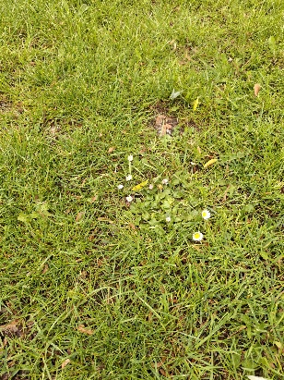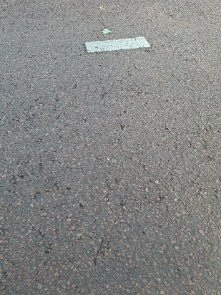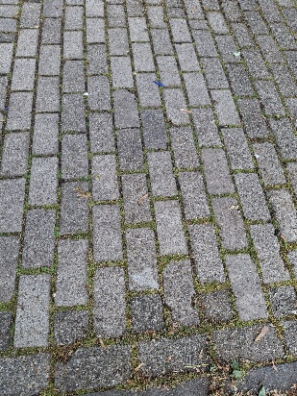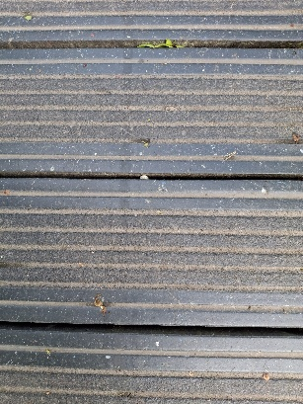
The pictures of the following roads: grass, asphalts, brick and wood. It had rain, so they where a little bit wet.

Pictures of the setup
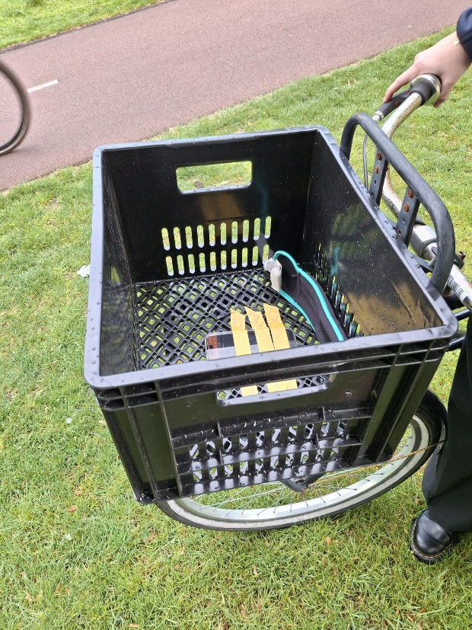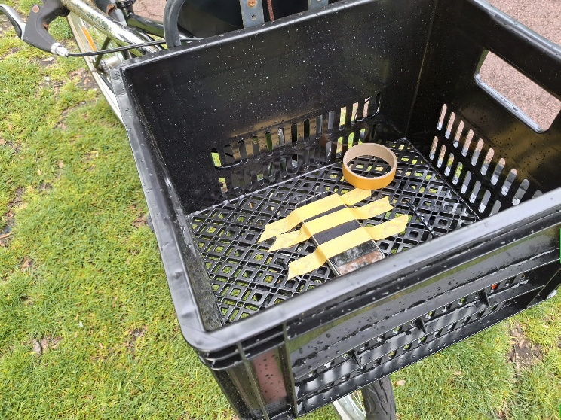

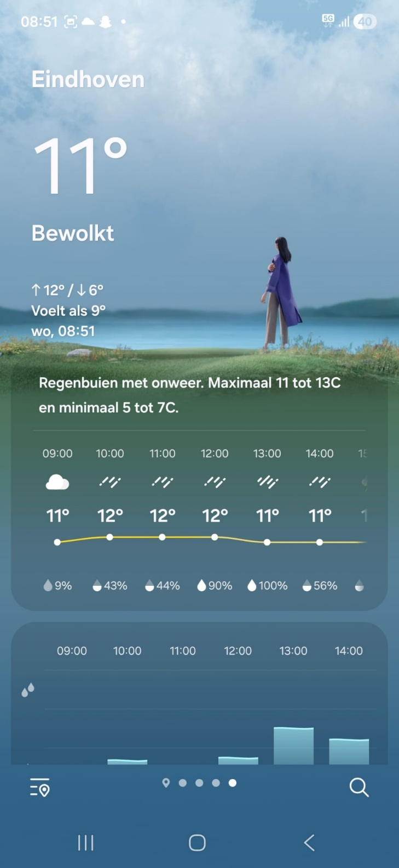
Weather prospects

description of the structure and variables in the dataset

Road types
The road types are underneath the column road types. There are 4 different roads, they’re named Asphalts, Grass, Bricks and Wood.

Weights
The weights are listed underneath the column weights. the weights are registered in Kilograms. There are five different weights: 0, 0.5, 1, 1.5 and 2 kg.

Weather
There is also a column named weather. this column shows what temperature it was during the recording of the data.

snapshot of the data

voorbeeld van Asfalt_0_second_0.csv
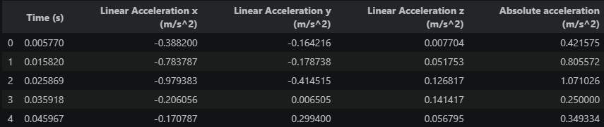

csv_with_other_factors.csv
